**Mechanics Project 2 - Arpen Matinyan**

1. Here is the force diagram for all the bodies.

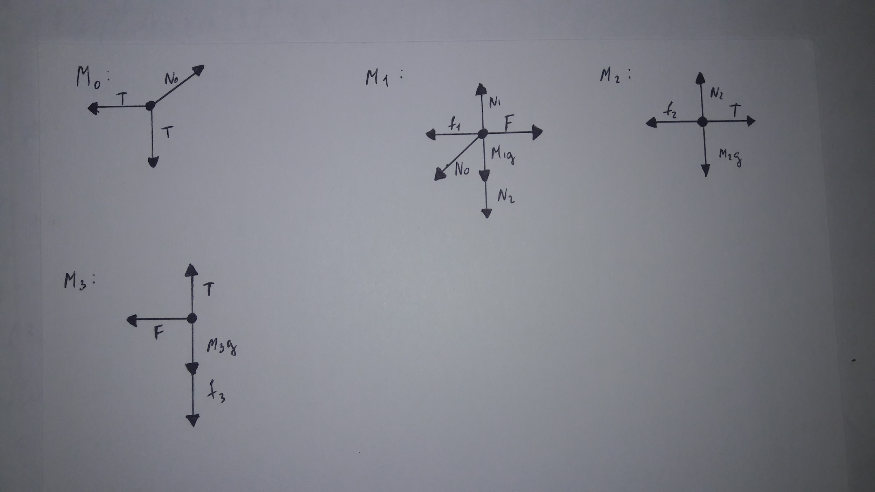

Where f1, f2 and f3 are the friction forces.

f1 = μ1 * N1 = μ1 *(M1*g + M2*g + T)

f2 = μ2 * M2 * g

f3 = μ3 * F

1. Constraint equations.

a1 - a2 - a3y = 0

a1 = a3x

Equations of motion.

M1*a1 = F - f1 - T

M2*a2 = T - f2

M3*a3y = T - M3*g - f3

-F1 = M3*a3x

1. The equations are solved. New position is computed using r(t) = r0 + v0t +a/2 * t^2.
2. Interesting cases are when M2 and M3 start to move, or when M1 moves as a result of the force applied by the pulley.

When M1 is greater than M2 and M3, μ1=μ2=μ3=0.1

For M3 to move vertically up the following condition must hold.

T >M3*g + f3

And meantime for M2 to move right : T < μ2 * M2 * g

So, if M3*g + μ3 * F < μ2 * M2 * g holds => the bodies M2 and M3 will move.

When M1 is stable, M3 will go down if M3> μ2 * M2.

|  |  |  |  |
| --- | --- | --- | --- |
| F = 100 N | a1 = -10.84  (-5.45 , 15) | a2 = -2.19  (0.92, 15) | a3x=-10.84, a3y=8.65  (-5.45, 8.35) |
| F = -50 N | a1 = 0.73 | a2=4.02 | a3x=0.73, a3y=3.29 |
| M1 = 1 << M2,M3 | a1 = 5.83 | a2=5.93 | a3x=5.83, a3y=0.10 |
| M1 = M2 = M3, |  |  |  |
|  |  |  |  |